

DBMS Lab File

(2024)

|  |  |
| --- | --- |
| Made by – | |
| Name  Course  Sap Id | Satvik Raj  B. tech CSE  500119624 |

# Experiment 3: To understand DDL and DML Command

**Objective:** To understand the concept of designing issue related to the database with creating, populating the tables. To understand the concept of data constraints that is enforced on data being stored in the table. Focus on Primary Key and the Foreign Key.

## Create the tables forCompany database as per ER diagram of Exp 2.

|  |  |
| --- | --- |
| Create TABLE employee (  Fname VARCHAR(15) NOT NULL,  Minit CHAR(1),  Lname VARCHAR(15) NOT NULL,  Ssn CHAR(9) NOT NULL,  Bdate DATE,  Address VARCHAR(30),  Sex CHAR(1),  Salary DECIMAL(10,2),  Super_ssn CHAR(9),  Dno INT,  PRIMARY KEY (Ssn),  FOREIGN KEY (Super_ssn) REFERENCES employee(Ssn)  ); |  |

|  |  |
| --- | --- |
| CREATE TABLE department (  Dname VARCHAR(15) NOT NULL,  Dnumber INT NOT NULL,  Mgr_ssn CHAR(9) NOT NULL,  Mgr_start_date DATE,  PRIMARY KEY (Dnumber),  UNIQUE (Dname),  FOREIGN KEY (Mgr_ssn) REFERENCES employee(Ssn)  ); |  |

ALTER TABLE employee ADD FOREIGN KEY (Dno) REFERENCES DEPARTMENT(Dnumber);

|  |  |
| --- | --- |
| CREATE TABLE dept_locations(  Dnumber INT NOT NULL,  Dlocation VARCHAR(15) NOT NULL,  PRIMARY KEY (Dnumber, Dlocation),  FOREIGN KEY (Dnumber) REFERENCES DEPARTMENT(Dnumber)  ); |  |

|  |  |
| --- | --- |
| CREATE TABLE project(  Pname VARCHAR(15) NOT NULL,  Pnumber INT NOT NULL,  Plocation VARCHAR(15),  Dnum INT NOT NULL,  PRIMARY KEY (Pnumber),  UNIQUE (Pname),  FOREIGN KEY (Dnum) REFERENCES DEPARTMENT(Dnumber)  ); |  |

|  |  |
| --- | --- |
| CREATE TABLE works_on(  Essn CHAR(9) NOT NULL,  Pno INT NOT NULL,  Hours DECIMAL(3,1),  PRIMARY KEY (Essn, Pno),  FOREIGN KEY (Essn) REFERENCES EMPLOYEE(Ssn),  FOREIGN KEY (Pno) REFERENCES PROJECT(Pnumber)  ); |  |

|  |  |
| --- | --- |
| CREATE TABLE dependent(  Essn CHAR(9) NOT NULL,  Dependent_name VARCHAR(15) NOT NULL,  Sex CHAR,  Bdate DATE,  Relationship VARCHAR(8),  PRIMARY KEY (Essn, Dependent_name),  FOREIGN KEY (Essn) REFERENCES EMPLOYEE(Ssn)  ); |  |

## Insert the following data into their respective tables of Company database.

INSERT INTO employee (Fname, Minit, Lname, Ssn, Bdate, Address, Sex, Salary, Super_ssn) VALUES

('James', '', 'Borg', '888665555', '1937-11-10', '450 Stone, Houston TX', 'M', 55000.00, NULL),

('Franklin', '', 'Wong', '333445555', '1965-12-08', '638 Voss, Houston TX', 'M', 40000.00, '888665555'),

('Jennifer', '', 'Wallace', '987654321', '1941-06-20', '291 Berry, Bellaire TX', 'F', 43000.00, '888665555'),

('Joyce', '', 'English', '453453453', '1972-07-31', '5631 Rice, Houston TX', 'F', 25000.00, '333445555'),

('Alicia', '', 'Zelaya', '999887777', '1968-01-19', '3321 Castle, Spring TX', 'F', 25000.00, '987654321'),

('Ramesh', '', 'Narayan', '666884444', '1962-09-15', '975 Fire Oak, Humble TX', 'M', 38000.00, '333445555'),

('Ahmad', '', 'Jabbar', '987987987', '1969-03-29', '980 Dallas, Houston TX', 'M', 25000.00, '987654321'),

('John', '', 'Smith', '123456789', '1965-01-09', '731 Fondren, Houston TX', 'M', 30000.00, '333445555');

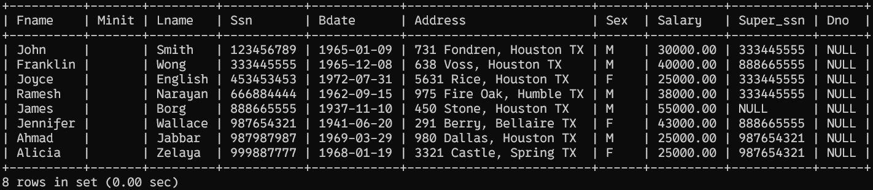

INSERT INTO DEPARTMENT VALUES

('Headquarters',1,'888665555','1981-06-19'),

('Research', 5, '333445555','1988-05-22'),

('Administration',4,'987654321','1995-01-01');

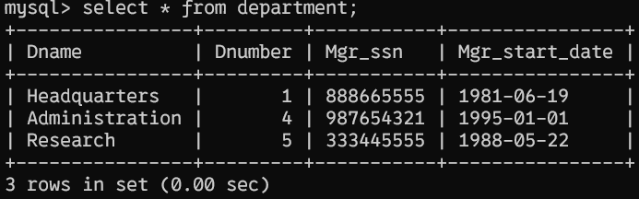

UPDATE employee SET Dno = '5' WHERE (Ssn = '123456789');

UPDATE employee SET Dno = '5' WHERE (Ssn = '333445555');

UPDATE employee SET Dno = '5' WHERE (Ssn = '453453453');

UPDATE employee SET Dno = '5' WHERE (Ssn = '666884444');

UPDATE employee SET Dno = '1' WHERE (Ssn = '888665555');

UPDATE employee SET Dno = '4' WHERE (Ssn = '987654321');

UPDATE employee SET Dno = '4' WHERE (Ssn = '987987987');

UPDATE employee SET Dno = '4' WHERE (Ssn = '999887777');

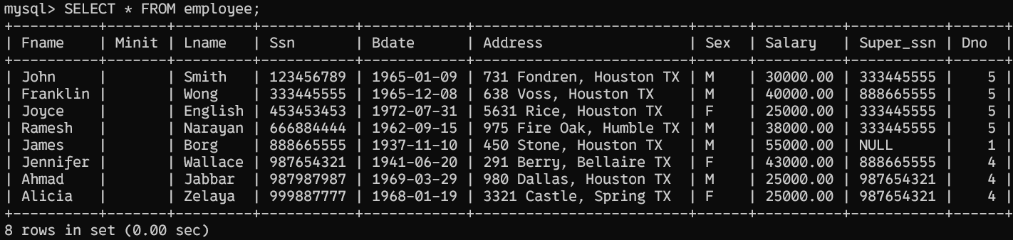

INSERT INTO project (Pname, Pnumber, Plocation, Dnum) VALUES

('ProductX', 1, 'Bellaire', 5),

('ProductY', 2, 'Sugarland', 5),

('ProductZ', 3, 'Houston', 5),

('Computerization', 10, 'Stafford', 4),

('Reorganization', 20, 'Houston', 1),

('Newbenefits', 30, 'Stafford', 4);

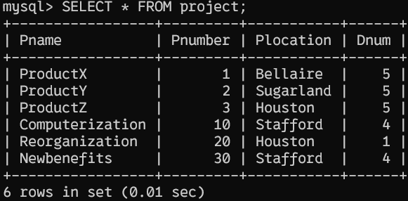

|  |  |
| --- | --- |
| INSERT INTO works_on (Essn, Pno, Hours) VALUES  ('123456789', 1, 32.5),  ('123456789', 2, 7.5),  ('666884444', 3, 40.0),  ('453453453', 1, 20.0),  ('453453453', 2, 20.0),  ('333445555', 2, 10.0),  ('333445555', 3, 10.0),  ('333445555', 10, 10.0),  ('333445555', 20, 10.0),  ('999887777', 30, 30.0),  ('999887777', 10, 10.0),  ('987987987', 10, 35.0),  ('987987987', 30, 5.0),  ('987654321', 30, 20.0),  ('987654321', 20, 15.0),  ('888665555', 20, NULL); |  |

INSERT INTO dependent (Essn, Dependent_name, Sex, Bdate, Relationship) VALUES

('333445555','Alice','F','1986-04-04','Daughter'),

('333445555','Theodore','M','1983-10-25','Son'),

('333445555','Joy','F','1958-05-03','Spouse'),

('987654321','Abner','M','1942-02-28','Spouse'),

('123456789','Michael','M','1988-01-04','Son'),

('123456789','Alice','F','1988-12-30','Daughter'),

('123456789','Elizabeth','F','1967-05-05','Spouse');

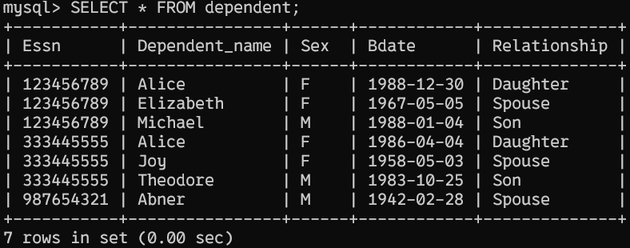

|  |  |
| --- | --- |
| INSERT INTO dept_locations VALUES  (1,'Houston'),  (4,'Stafford'),  (5,'Bellaire'),  (5,'Houston'),  (5,'Sugarland'); |  |

# Experiment 4:  To understand and apply the concept of Constraints.

**Objective:** To understand the concept of data constraints that is enforced on data being stored in the table. Focus on Primary Key and the Foreign Key.

1. **Create the tables described below:**
   1. **Table name: CLIENT_MASTER**

**Description:** used to store client information

|  |  |
| --- | --- |
| CREATE TABLE CLIENT_MASTER(  `CLIENTNO` varchar(6) NOT NULL,  `NAME` varchar(20) NOT NULL,  `ADDRESS 1` varchar(30),  `ADDRESS 2` varchar(30),  `CITY` varchar(15),  `PINCODE` INT,  `STATE` varchar(15),  `BALDUE` Decimal(10,2),  CONSTRAINT CHK_CLIENTNO CHECK (`CLIENTNO` LIKE 'c%'),  PRIMARY KEY(`CLIENTNO`)  ); |  |

* 1. **Table Name: PRODUCT_MASTER**

**Description:**used to store product information

|  |  |
| --- | --- |
| CREATE TABLE PRODUCT_MASTER(  `PRODUCTNO` varchar(6),  `DESCRIPTION` varchar(15) NOT NULL,  `PROFITPERCENT` Decimal(4,2) NOT NULL,  `UNIT MEASURE` varchar(10) NOT NULL,  `QTYONHAND` INT NOT NULL,  `REORDERLVL` INT NOT NULL,  `SELLPRICE` Decimal(8,2) NOT NULL,  `COSTPRICE` Decimal(8,2) NOT NULL,  PRIMARY KEY(PRODUCTNO),  CONSTRAINT CHK_PRODUCTNO CHECK (`PRODUCTNO` LIKE 'P%')  ); |  |

* 1. **Table Name: SALESMAN_MASTER**

**Description:** used to store salesman information working for the company.

|  |  |
| --- | --- |
| CREATE TABLE SALESMAN_MASTER(  `SALESMANNO` varchar(6),  `SALESMANNAME` varchar(20) NOT NULL,  `ADDRESS 1` varchar(30) NOT NULL,  `ADDRESS 2` varchar(30),  `CITY` varchar(20),  `PINCODE` INT,  `STATE` varchar(20),  `SALAMT` real NOT NULL,  `TGTTOGET` Decimal(6,2) NOT NULL,  `YTDSALES` Double NOT NULL,  `REMARKS` varchar(60) ,  CONSTRAINT CHK_NOZERO CHECK(TGTTOGET > 0 AND SALAMT > 0),  PRIMARY KEY(SALESMANNO)  ); |  |

1. **Insert the following data into their respective tables:**

INSERT INTO CLIENT_MASTER (`CLIENTNO`, `NAME`, `ADDRESS 1`, `ADDRESS 2`, `CITY`, `PINCODE`, `STATE`, `BALDUE`) VALUES

('C00001','Ivan bayross',NULL,NULL,'Mumbai',400054,'Maharashtra',15000 ),

('C00002','Mamta muzumdar',NULL,NULL,'Madras',780001,'Tamil Nadu',0 ),

('C00003','Chhaya bankar',NULL,NULL,'Mumbai',400057,'Maharashtra',5000 ),

('C00004','Ashwini joshi',NULL,NULL,'Bangalore',560001,'Karnataka',0 ),

('C00005','Hansel colaco',NULL,NULL,'Mumbai',400060,'Maharashtra',2000 ),

('C00006','Deepak sharma',NULL,NULL,'Mangalore',560050,'Karnataka',0 );

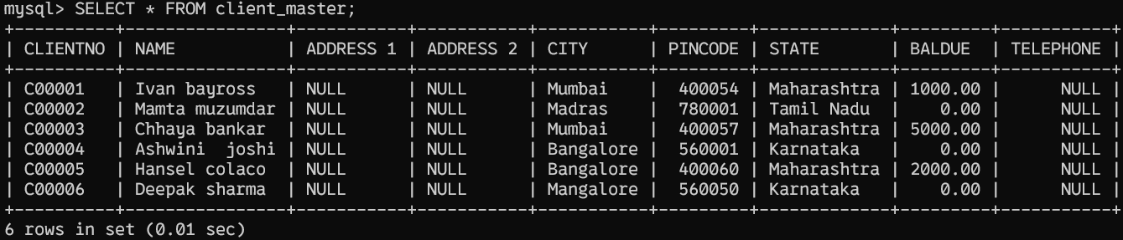

INSERT INTO PRODUCT_MASTER (PRODUCTNO, DESCRIPTION, PROFITPERCENT,`UNIT MEASURE` , QTYONHAND, REORDERLVL, SELLPRICE, COSTPRICE) VALUES

('P00001','T-Shirt',5,'Piece',200,50,350,250),

('P0345','Shirts',6,'Piece',150,50,500,350),

('P06734','Cotton jeans',5,'Piece',100,20,600,450),

('P07865','Jeans',5,'Piece',100,20,750,500),

('P07868','Trousers',2,'Piece',150,50,850,550),

('P07885','Pull Overs',2.5,'Piece',8/0,30,700,450),

('P07965','Denim jeans',4,'Piece',100,40,350,250),

('P07975','Lycra tops',5,'Piece',70,30,300,175),

('P08865','Skirts',5,'Piece',75,30,450,300);

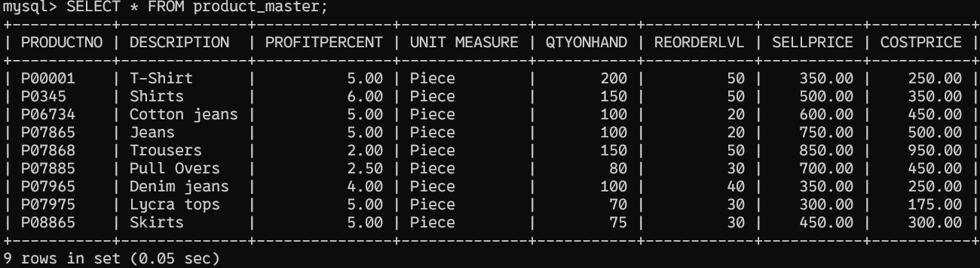

INSERT INTO SALESMAN_MASTER(SALESMANNO, SALESMANNAME, `ADDRESS 1`, `ADDRESS 2`, CITY, PINCODE, STATE, SALAMT, TGTTOGET, YTDSALES, REMARKS) VALUES

('S00001', 'Aman', 'A/14', 'Worli', 'Mumbai', 400002, 'Maharashtra', 30000, 5000.00, 63200, NULL),

('S00002', 'Omkar', '65', 'Nariman', 'Mumbai', 400001, 'Maharashtra', 26000, 3000.00, 32410, NULL),

('S00003','Raj','P-7', 'Bandra', 'Mumbai', 400032, 'Maharashtra', 57000, 6000.00, 102300, NULL),

('S00004','Ashish','A/5','Juhu','Mumbai',400044,'Maharashtra',18000,2000.00,12030,NULL);

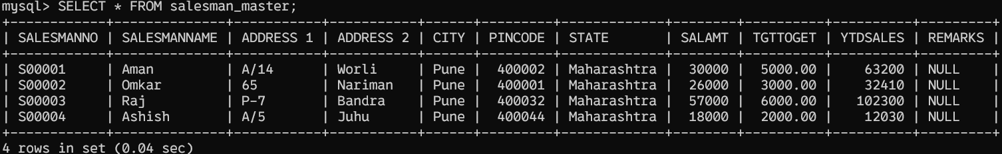

1. **Exercise on retrieving records from a table.**
   * 1. Find out the names of all the clients.

|  |
| --- |
| SELECT CLIENT_MASTER.NAME FROM CLIENT_MASTER; |
|  |

* + 1. Retrieve the entire contents of the Client_Master table.

|  |
| --- |
| SELECT * FROM CLIENT_MASTER; |
|  |

* + 1. Retrieve the list of names, city and the state of all the clients.

|  |
| --- |
| SELECT CLIENT_MASTER.NAME, CLIENT_MASTER.CITY, CLIENT_MASTER.STATE FROM CLIENT_MASTER; |
|  |

* + 1. List the various products available from the Product_Master table.

|  |
| --- |
| SELECT * FROM PRODUCT_MASTER; |
|  |

* + 1. List all the clients who are located in Mumbai.

|  |
| --- |
| SELECT * FROM CLIENT_MASTER WHERE CLIENT_MASTER.CITY = 'Mumbai'; |
|  |

* + 1. Find the names of salesman who have a salary equal to Rs.30000.

|  |
| --- |
| SELECT * FROM SALESMAN_MASTER WHERE SALESMAN_MASTER.SALAMT = 30000; |
|  |

1. **Exercise on updating records in a table**
   * 1. Change the city of ClientNo ‘C00005’ to ‘Bangalore’.
     2. Change the BalDue of ClientNo ‘C00001’ to Rs.1000.
     3. Change the cost price of ‘Trousers’ to rs.950.00.
     4. Change the city of the salesman to Pune.
2. **Exercise on deleting records in a table**
   * 1. Delete all salesman from the Salesman_Master whose salaries are equal to Rs.3500.
     2. Delete all products from Product_Master where the quantity on hand is equal to 100.
     3. Delete from Client_Master where the column state holds the value ‘Tamil Nadu’.
3. **Exercise on altering the table structure**
   * + 1. Add a column called ‘Telephone’ of data type integer to the Client_Master table.
       2. Change the size off SellPrice column in Product _Master to 10, 2.
4. **Exercise on deleting the table structure along with the data**
   * + 1. Destroy the table Client_Master along with its data.